AI WEATHERWISE API
Mongoose Schema Definitions – Location Schema
Naan Mudhalvan – Skill Wallet Group Project

1. Introduction
The AI WeatherWise API uses Mongoose schemas to define the structure of data stored in MongoDB. The Location schema represents a user's saved location and contains the city, country, and user reference. Validation rules are included to ensure required values are provided, while a compound unique index prevents the same user from saving the exact same city and country more than once.

2. Location Schema
The Location schema shown in the project is implemented as follows:
const mongoose = require('mongoose');
const locationSchema = new mongoose.Schema({
city: {
type: String,
required: [true, 'Please provide a city name'],
trim: true
},
country: {
type: String,
required: [true, 'Please provide a country name'],
trim: true
},
user: {
type: mongoose.Schema.Types.ObjectId,
ref: 'User',
required: [true, 'User reference is required']
}
}, {
timestamps: true
});
// Ensure a user cannot duplicate the exact same city and country in their favorites
locationSchema.index({ user: 1, city: 1, country: 1 }, { unique: true });
const Location = mongoose.model('Location', locationSchema);
module.exports = Location;

3. Schema Field Explanation
Field | Type / Rule | Purpose
city | String; required; trim | Stores the city name. A validation message is displayed if the city is missing.
country | String; required; trim | Stores the country name. A validation message is displayed if the country is missing.
user | ObjectId; ref: User; required | Connects the saved location to the corresponding User document.

4. Required Validation
The city and country fields use Mongoose's required validation. The custom validation messages make it clear why a document cannot be saved when either value is missing.
required: [true, 'Please provide a city name']
required: [true, 'Please provide a country name']

5. Trim Option
The trim: true option removes unnecessary leading and trailing whitespace from city and country values. This helps maintain cleaner and more consistent location data.

6. User Reference
user: {
type: mongoose.Schema.Types.ObjectId,
ref: 'User',
required: [true, 'User reference is required']
}
The user field stores the MongoDB ObjectId of the associated user. The ref: 'User' option tells Mongoose that this ObjectId refers to a document in the User model. This creates a relationship between the user and the locations saved by that user.

7. Timestamps
{ timestamps: true }
Enabling timestamps automatically adds createdAt and updatedAt fields to each Location document. These fields help track when a location was created and when it was last modified.

8. Compound Unique Index
locationSchema.index(
{ user: 1, city: 1, country: 1 },
{ unique: true }
);
The compound unique index combines the user, city, and country fields. It prevents one user from creating duplicate favorite-location records for the same city and country while still allowing different users to save the same location.

9. Creating and Exporting the Model
const Location = mongoose.model('Location', locationSchema);
module.exports = Location;
mongoose.model() converts the schema into a Mongoose model named Location. Exporting the model allows other backend files, such as controllers and routes, to import it and perform database operations such as creating, reading, updating, or deleting locations.

10. Example Location Document
{
"city": "Chennai",
"country": "India",
"user": "USER_OBJECT_ID",
"createdAt": "2026-10-05T00:00:00.000Z",
"updatedAt": "2026-10-05T00:00:00.000Z"
}

11. Benefits of the Location Schema
- Provides a consistent structure for storing saved locations.
- Validates that city, country, and user information is supplied.
- Uses a User reference to associate each location with its owner.
- Automatically records creation and modification times.
- Prevents duplicate city-country favorites for the same user.
- Can be reused by API controllers and routes throughout the WeatherWise backend.

12. Project Screenshot
The following screenshot shows the Location Schema Definition provided in the AI WeatherWise API project.
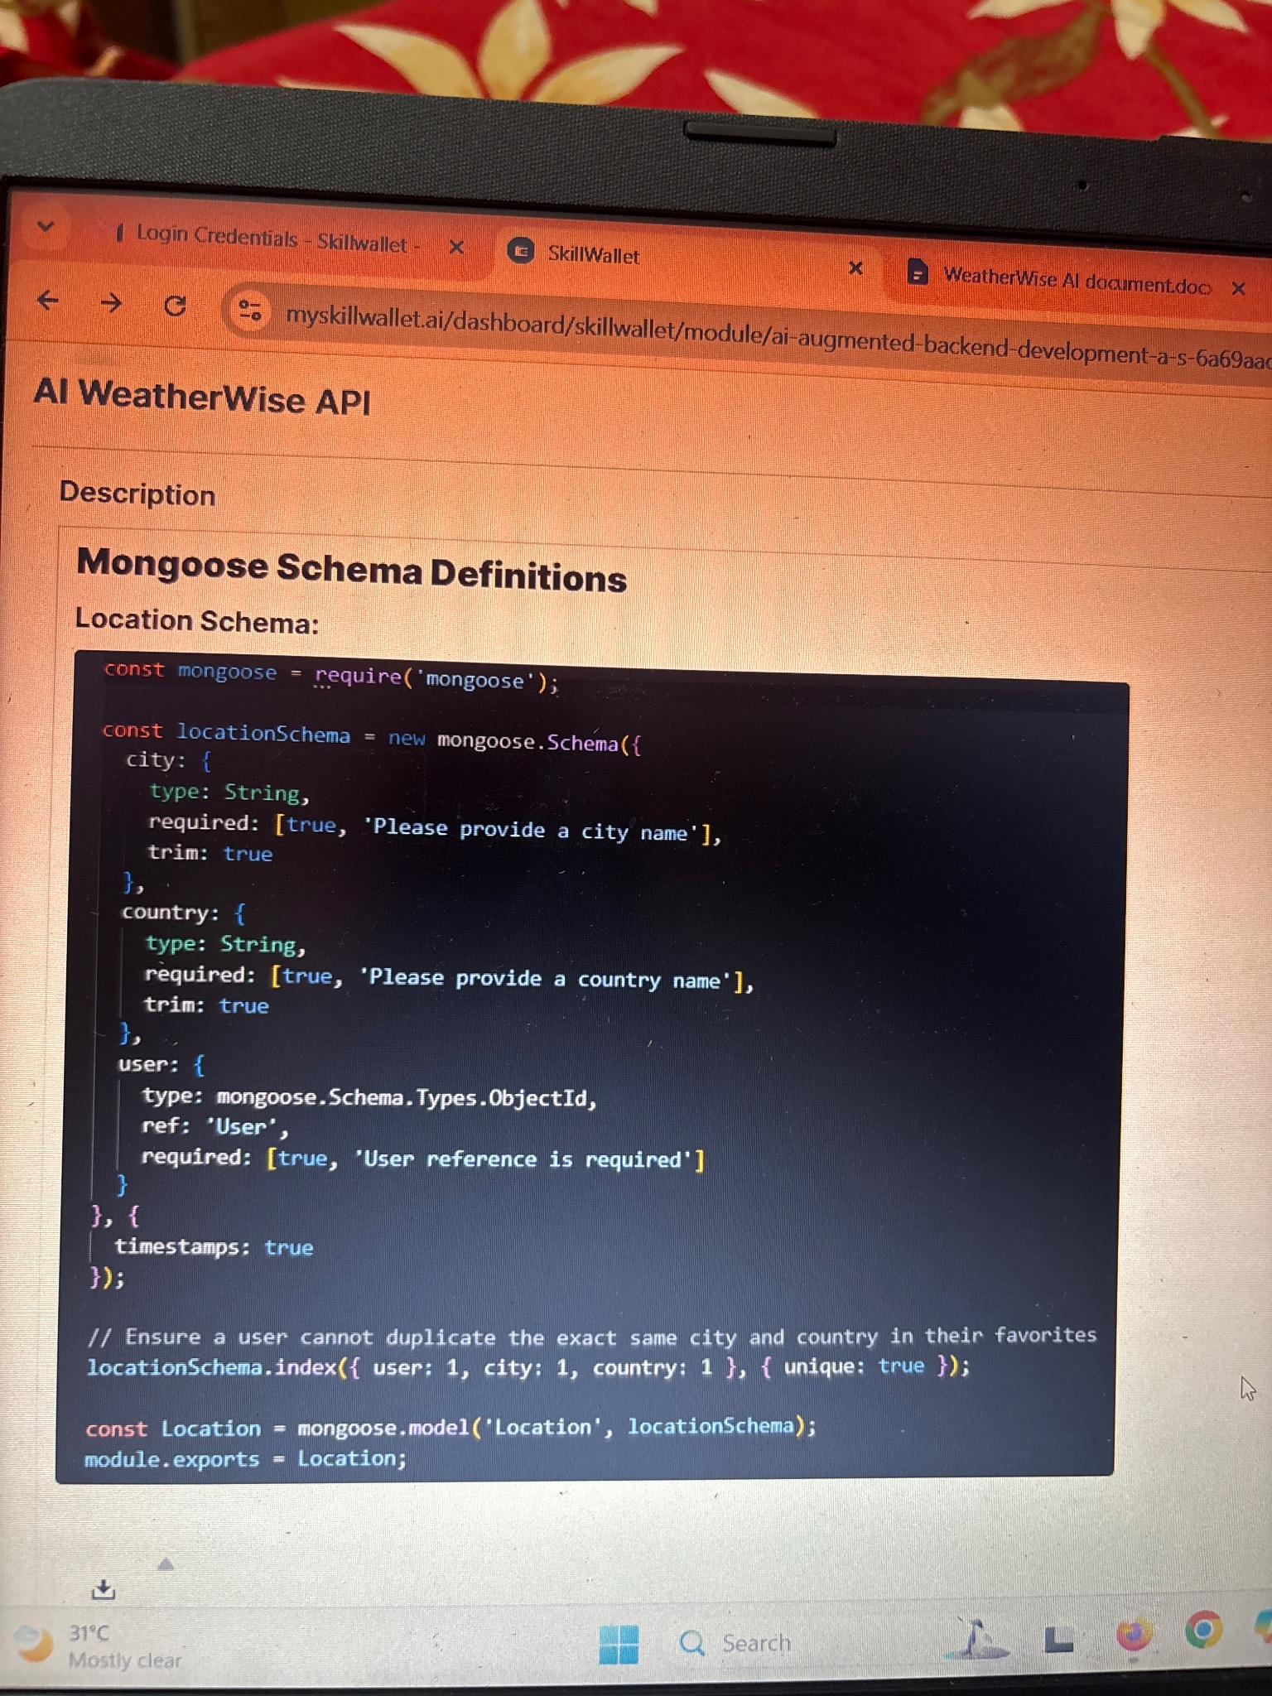

13. Conclusion
The Location Mongoose schema provides a structured and reliable way to store users' favorite weather locations. Required validation, user references, timestamps, and the compound unique index improve data quality and prevent duplicate records. The resulting Location model can then be used throughout the AI WeatherWise API for location management and weather-related features.

